**Pomona College Hazardous Waste Disposal Guideline**

**Labeling of Hazardous Waste**

All hazardous waste containers must be labeled with the words **Hazardous Waste** along with the name of the chemical constituents, the approximate percentage of each chemical constituent, the associated hazard(s) of the waste, and the accumulation date (the date the waste is first generated). Waste label can be obtained by contacting the Environmental Safety Manager at x71668. It is important to have the waste label filled out prior to generating the waste. Make sure to fill out all required information on the waste label. When writing the chemical constituents, use the IUPAC or full chemical names (in English). Do not use symbols, abbreviations, structural diagrams or product trade names. Make sure to write legibly and accurately. Once the waste label is filled out, print it and fold it and place it in the packing list envelope. Attach the packing list envelope to the side of the waste container.

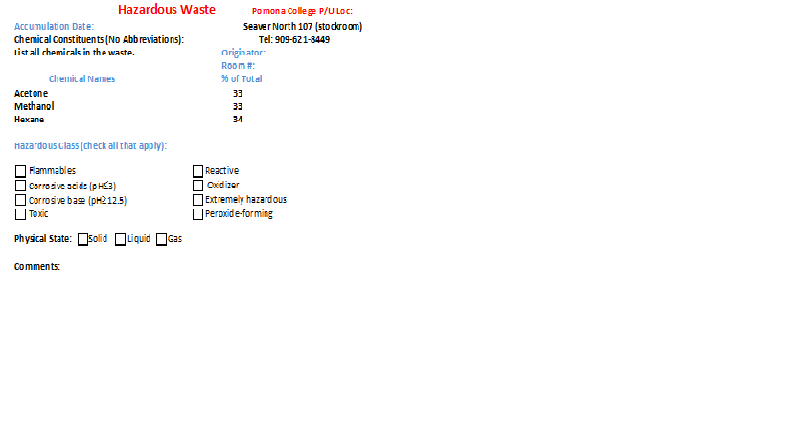

Date the waste was

first generated Generator name

Full name of the approximate percentage of chemical

chemical constituents.

Do not use abbreviations

Or chemical formula

Chemical hazardous

properties

Physical state of the

Chemical

**Packaging of Chemical Waste**

* Do not dispose of hazardous waste in the drains or trash.
* Place all hazardous waste in a sealable container. The waste container must be in good condition and free from exterior contamination.
* When choosing the waste container, make sure that the waste is compatible with the container it is stored in (e.g. no hydrofluoric acid in glass).
* Do not store incompatible hazardous chemical waste together.
* The container must be kept closed at all times unless when actively receiving waste.
* Do not fill the container with waste more than 90%. This will leave headspace for expansion of the contents during transportation of the waste.
* Dry waste must be double bagged in clear plastic bag.
* Liquid waste must be separated from solid waste.
* Find a designated place in the laboratory to store hazardous waste.
* Hazardous waste container must be stored in secondary container.

**Chemical Waste Segregation Guidelines**

* Do not store acids and bases together
* Do not store organic acids and mineral acids together
* Store flammable chemicals separately

-Do not store flammables with oxidizer, oxidizing acids, or corrosive

* Do not store water reactive chemicals with aqueous based compounds
* Always refer to the MSDS for information.

**Disposal of Empty Container Procedures**

**Dispose as Hazardous Waste**

* Empty containers that once held hazardous chemicals must be disposed as hazardous waste if the container is bigger than 5 gallons.
* Empty containers that once held extremely hazardous waste (any size must also be disposed of hazardous waste).

**Dispose as non-hazardous waste**

* Empty container that once held hazardous chemical can be disposed in the trash can if it is less than 5 gallons. However, the container must be triple rinsed with water or other suitable solvent and air-dried before disposal (make sure to check for chemical compatibility before using a solvent for rinsing). Before putting the empty bottle in the trash can, make sure that the original label is covered over or defaced completely and has the world “**EMPTY**” on the container.
* If the container is made up of glass and it is broken, it must be placed in a “Broken Glass” container.

**Aerosol Cans:**

* In order to dispose aerosol can in a regular trash can, the aerosol container must be completely empty of product and propellant. The spray mechanism or nozzles must be in place and functional.
* Aerosol cans that once held pesticides, flammable propellants or extremely hazardous chemicals must be disposed as hazardous waste.

**Transportation of hazardous chemicals**

Hazardous chemical that are being transported between laboratories or buildings must be clearly labeled with the chemical name. Hand-written labels are acceptable. When using carts for transporting hazardous materials, the carts must have sides, on each shelf, that are high enough to retain the containers. The cart wheels must be large enough to prevent the carts from being caught in floor cracks and door and elevator thresholds.

An approved secondary container is used to transport hazardous chemical when not using a cart. The secondary container need to have a carrying handle that is large enough to hold the chemical if broken in transit. Rubber or plastic secondary containers are acceptable. Staff transporting hazardous chemical must wear lab coat, safety glass, and disposable gloves (remember the “one-hand rule”).